

ST. LAWRENCE COLLEGE

**Chabahil, Kathmandu**

**Subject: CS**

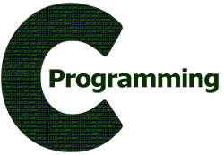 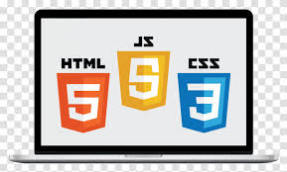

**PROJECT WORK**

**ON**

**C PROGRAMMING AND JAVASCRIPT**

**Submitted by:**

**Name:**

**Grade: XII**

**Faculty: Science**

**Section:**

**Reg. no:**

**Internal Examiner External Examiner**

**For The Partial Fulfillment Of The Requirement For Grade 12 Computer Science Course Designed By NEB**

**2021/22 AD**

Please print it in the color page according to the section

Section a: light blue color

Section b: light green color

Section c: yellow color

Section d: pink color